PRANVEER SINGH INSTITUTE OF TECHNOLOGY, KANPUR

**DEPARTMENT OF COMPUTER SCIENCE & ENGINEERING**

**Even Semester 2022-23**



**B. Tech.- Third Year**

**Semester- VI**

**Lab File**

WEB TECHNOLOGY

(KCS652)

|  |  |  |  |
| --- | --- | --- | --- |
| **Submitted To :** | | **Submitted By :** | |
| **Faculty Name** | **:_________________** | **Name** | **:_________________** |
| **Designation** | **:_________________** | **Roll No.** | **:_________________** |
|  |  | **Section** | **:_________________** |

|  |  |  |  |  |
| --- | --- | --- | --- | --- |
| **INDEX** | | | | |
| **Lab No.** | **Objective** | **Date** | **Marks** | **Sign.** |
| **1** | Write HTML/Java scripts to display your CV in navigator, your Institute website, Department Website and Tutorial website for specific subject. |  |  |  |
| **2** | Write an HTML program to design an entry form of student details |  |  |  |
| **3** | Write program using Java script for Web Page to display browsers information. |  |  |  |
| **4** | A super class Detail has been defined to store the details of a customer. Define a subclass Bill to compute the monthly telephone charge of the customer as per the chart given below:  Number of Calls Rate  1 – 100 Only Rental charge  101 – 200 60 paisa per call + rental charge  201 – 300 80 paisa per call + rental charge  Above 300 1 rupee per call + rental charge |  |  |  |
| **5** | Write a Java applet/AWT to display the Application Program screen i.e. calculator and other. |  |  |  |
| **6** | Write a Java applet to display the Application Program screen i.e. Colour mixer pallet |  |  |  |
| **7** | Write a program using TCP/IP socket between client and server and perform two-way communication |  |  |  |
| **8** | Write a program to illustrate JDBC connectivity and perform CRUD operation on a table student/employee (at least 5 attributes) |  |  |  |
| **9** | Write a program to illustrate Batch Transaction with prepared statement |  |  |  |
| **10** | Install a database (Mysql or Oracle). Create a table which should contain at least the following fields: name, password, email-id, phone number Write a java program/servlet/JSP to connect to that database and extract data from the tables and display them. Insert the details of the users who register with the web site, whenever a new user clicks the submit button in the registration page. |  |  |  |
| **11** | To Develop a student Marks sheet by using Servlet and HTML with database Oracle. |  |  |  |
| **12** | Design and implement a simple servlet for an entry form of student details and send it to store at database server like SQL, Oracle or MS Access. |  |  |  |
| **13** | Write a JSP which insert the details of the 3 or 4 users who register with the web site by using registration form.  Authenticate the user when he submits the login form using the user name and password from the database |  |  |  |
| **14** | Store 5 Students (name, branch, rollno, age) objects in list. Perform any sorting technique so as to display list in ascending order of rollno and display in descending order of age. |  |  |  |
| **15** | Perform union (AUB), intersection and difference (A-B) operations using set collection. |  |  |  |
| **16** | Create a Map that consists of Country-Capital pair to store information about various countries along with their capital name. Display the entries in sorted order of Country and Capital. |  |  |  |

**Program 1**

**Objective:** Write HTML/Java scripts to display your CV in navigator, your Institute website, Department Website and Tutorial website for specific subject.

**Code:**

<html>

<head>

    <title>RESUME </title>

</head>

<body> *<!-- BEGIN DIV FOR OVERALL BOX -->*

    <div id="resume"> *<!-- THIS DIV CENTERS OUR HEADING -->*

        <h1>Harsh Kumar Srivastava</h1>

        <h2>Armapur, estate</h2>

        <h2>Kanpur</h2> <br /> *<!-- END CENTERING DIV -->*

    </div>

    <h2>OBJECTIVE</h2>

    <p> Seeking a challenging position to work in any environment where I can show my workability with good analytical &

        technical skills to fulfill the organization's goals and objectives in the computer science field. </p> <br />

    <h2>EDUCATION</h2>

    <h3>Pranveer Singh Institute of Technology College of Engineering (PSIT COE), Kanpur </h3>

    <p> Graduating July 2024</p>

    <a href="/">www.psit.in</a>

    <ul>

        <li> Bachelor of Technology | Computer Science and Engineering with specialization in Artificial Intelligence &

            Machine Learning |

            2020-2024 | 79% (up to 4th semester)</li>

    </ul>

    <h2>Projects</h2>

    <h3>Student Placement Prediction</h3>

    <ul>

        <li> Developed a Machine learning model to predict the success of a student in getting placed based on their

            technical skills. Utilized Python, Flask, and HTML/CSS/Javascript to create a user-friendly web interface

            that

            provides accurate predictions</li>

        <li>Technologies used: Python, Flask, Machine Learning, HTML, CSS, Javascript.</li>

    </ul>

    <h3>Personal Bloging Website</h3>

    <p> 01/2022-03/2022 </p>

    <ul>

        <li> Developed a <strong>Node Js app</strong> that uses Firebase as its database and is used for writing blogs.

            Utilized HTML,

            CSS, and JavaScript to create a responsive and user-friendly web interface.</li>

        <li><strong>Technologyused: </strong> HTML, CSS, JavaScript, NodeJs</li>

    </ul> <br />

    <h2>Courses</h2>

    <ul>

        <li>Programming Foundations with Javascript, HTML and CSS </li>

        <p><a href="/">www.webdevelomentbootcamp</a></p>

        <li>Supervised machine learning: Regression and Classification </li>

        <p><a href="/">www.machinelearning</a></p>

        <li>Programming for Everybody </li>

        <p><a href="/">www.programmingforeverybody</a></p>

        <li>Technical Support Fundamentals </li>

        <p><a href="/">www.technicalsupportfundamentals</a></p>

    </ul>

    <p>To contact the departmant:</p>

    <div id="bottom">

        <p> <a href="/">Mr Sumit Chandra</a> | <a href="/">Mrs Saifali Raj</a> | <a href="/">Mr Anand Srivastava</a> |

            <a href="/" target="_blank">Mrs Preshika Singh</a>

        </p>

    </div>

</body>

</html>

**Output:-**

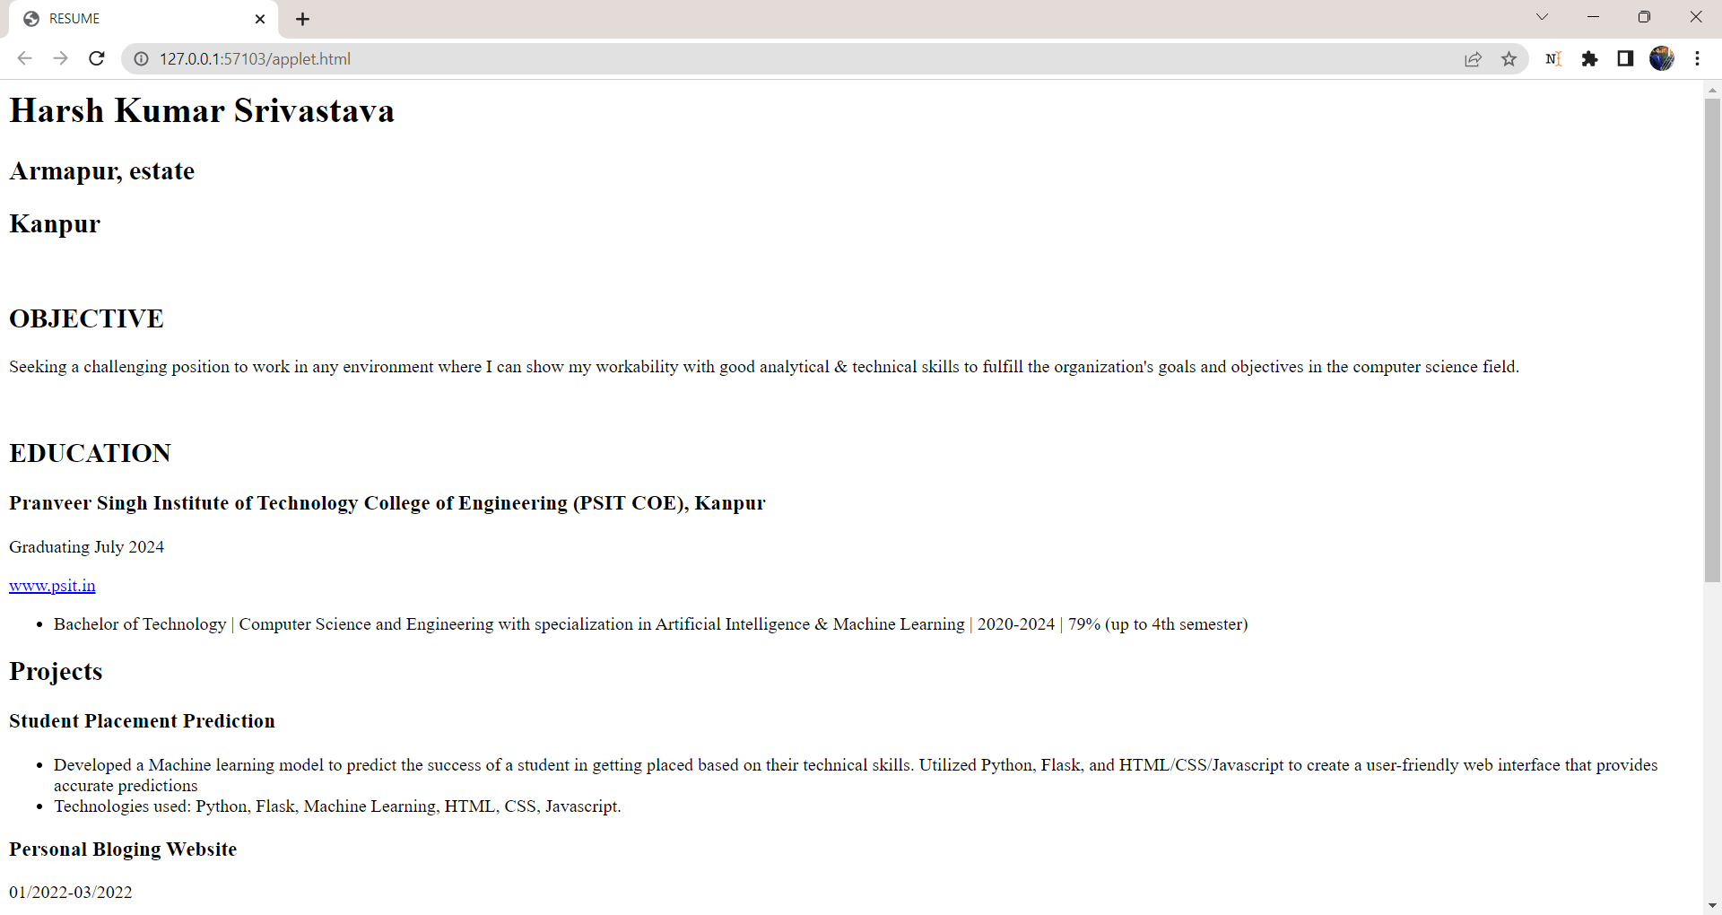

**PROGRAM-2**

**Objective:** Write an HTML program to design an entry form of student details

**Code:**

<html>

<head>

<script type="text/javascript" src="validate.js" ></script>

</head>

<style>

td{

font-size: 17px;

}

</style>

<body bgcolor="aqua" bolder="5" style="padding: 6rem;">

<form action="register.jsp" name="StudentRegistration" method=”post”>

<table cellpadding="2" width="50%" border="10" align="center"cellspacing="2">

<tr>

<td colspan=2>

<center><font size=6><b>Student Registration Form</b></font></center>

</td>

</tr>

<tr>

<td>Name</td>

<td><input type=text name=textnames id="textname" size="35"></td>

</tr>

<tr>

<td>Father Name</td>

<td><input type="text" name="fathername" id="fathername"

size="35"></td>

</tr>

<tr>

<td>Postal Address</td>

<td><input type="text" name="paddress" id="paddress" size="35"></td>

</tr>

<tr>

<td>Personal Address</td>

<td><input type="text" name="personaladdress"

id="personaladdress" size="35"></td>

</tr>

<tr>

<td>Sex</td>

<td><input type="radio" name="sex" value=

"male" size="10">Male

<input type="radio" name="sex" value="Female" size="10">Female</td>

</tr>

<tr>

<td>City</td>

<td><select name="City">

<option value="-1" selected>select..</option>

<option value="New Delhi">NEW DELHI</option>

<option value="Mumbai">MUMBAI</option>

<option value="Goa">GOA</option>

<option value="Patna">PATNA</option>

</select></td>

</tr>

<tr>

<td>Course</td>

<td><select name="Course">

<option value="-1" selected>select..</option>

<option value="B.Tech">B.TECH</option>

<option value="MCA">MCA</option>

<option value="MBA">MBA</option>

<option value="BCA">BCA</option>

</select></td>

</tr>

<tr>

<td>District</td>

<td><select name="District">

<option value="-1" selected>select..</option>

<option value="Nalanda">NALANDA</option>

<option value="UP">UP</option>

<option value="Goa">GOA</option>

<option value="Patna">PATNA</option>

</select></td>

</tr>

<tr>

<td>State</td>

<td><select Name="State">

<option value="-1" selected>select..</option>

<option value="New Delhi">NEW DELHI</option>

<option value="Mumbai">MUMBAI</option>

<option value="Goa">GOA</option>

<option value="Bihar">BIHAR</option>

</select></td>

</tr>

<tr>

<td>PinCode</td>

<td><input type="text" name="pincode" id="pincode" size="35"></td>

</tr>

<tr>

<td>EmailId</td>

<td><input type="text" name="emailid" id="emailid" size="35"></td>

</tr>

<tr>

<td>DOB</td>

<td><input type="text" name="dob" id="dob" size="35"></td>

</tr>

<tr>

<td>MobileNo</td>

<td><input type="text" name="mobileno" id="mobileno" size="35"></td>

</tr>

<tr>

<td><input type="reset"></td>

<td colspan="2"><input type="submit" value="Submit Form" /></td>

</tr>

</table>

</form>

</body>

</html>

**Output:-**

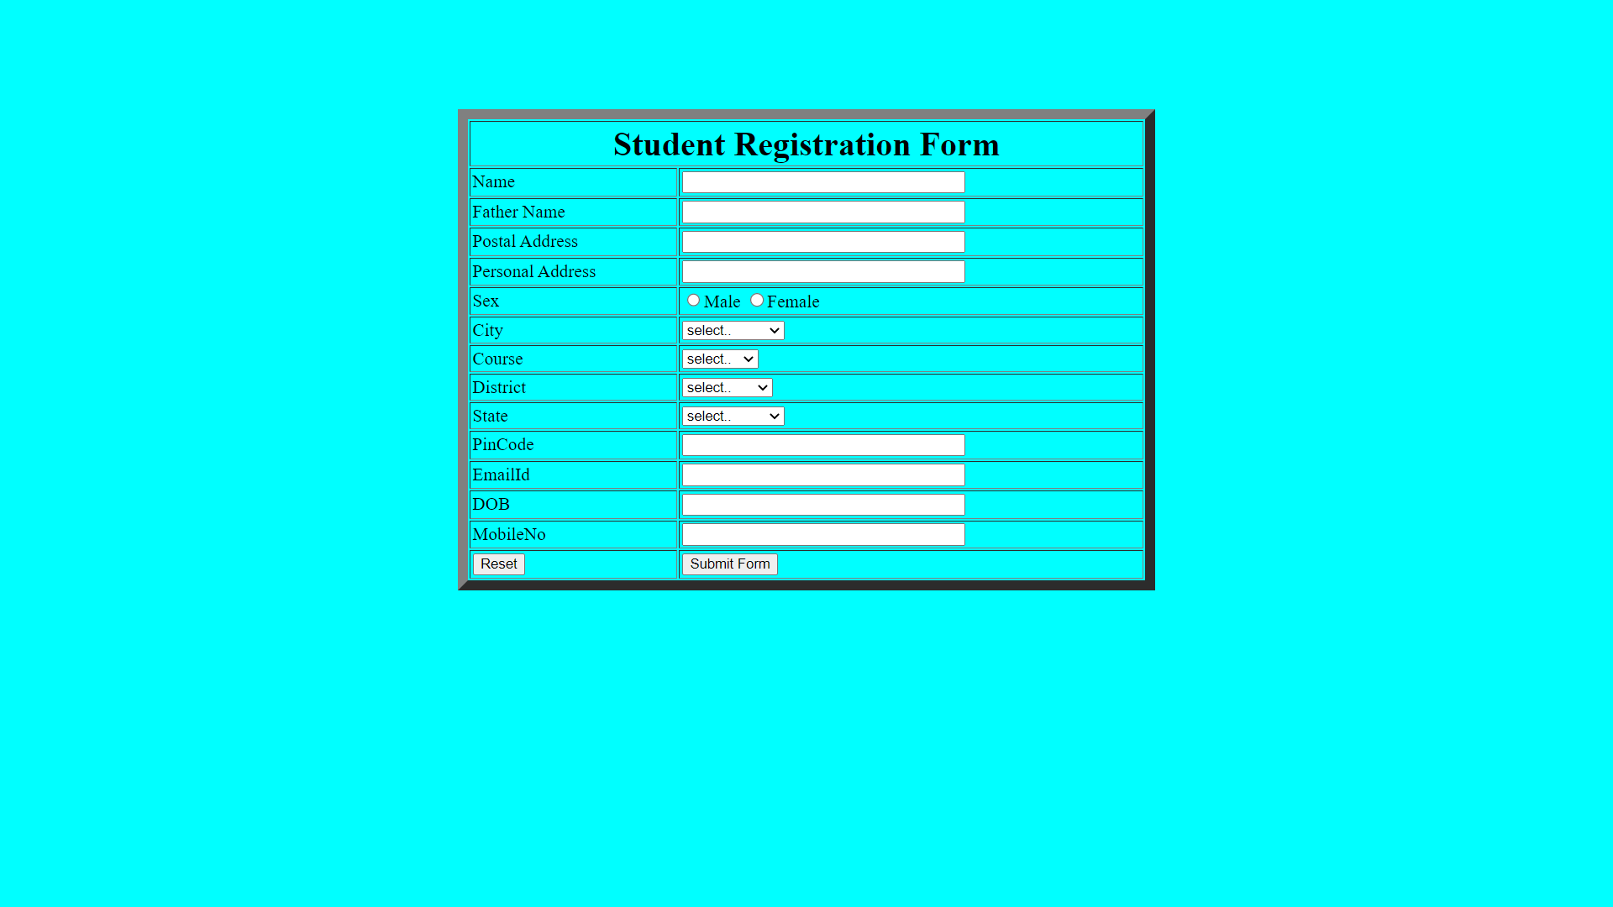

**PROGRAM- 3**

**Objective:** Write program using Java script for Web Page to display browsers information**.**

**Code:**

<html xmlns="http://www.w3.org/1999/xhtml" >

<head runat="server">

<title>Browser Information</title>

<script language=javascript>

function show()

{

document.write("Name "+navigator.appName+"<br>");

document.write("Version "+navigator.appVersion +"<br>");

document.write("Codename " +navigator.appCodeName +"<br>");

document.write("Cookie enable"+navigator.cookieEnabled +"<br>");

document.write("Java Enable"+navigator.javaEnabled +"<br>");

document.write("Mime type"+navigator.mimeTypes +"<br>");

document.write("Platform"+navigator.platform +"<br>");

document.write("Plug ins"+navigator.plugins +"<br>");

document.write("System Language"+navigator.systemLanguage +"<br>");

document.write("User language"+navigator.userAgent +"<br>");

document.write("User Agent"+navigator.userAgent +"<br>");

}

</script>

</head>

<body>

<form id="form1">

<div>

<input id="Button1" type="button" value="Click me" onclick="show()" />

</div>

</form>

</body>

</html>

**Output: -**

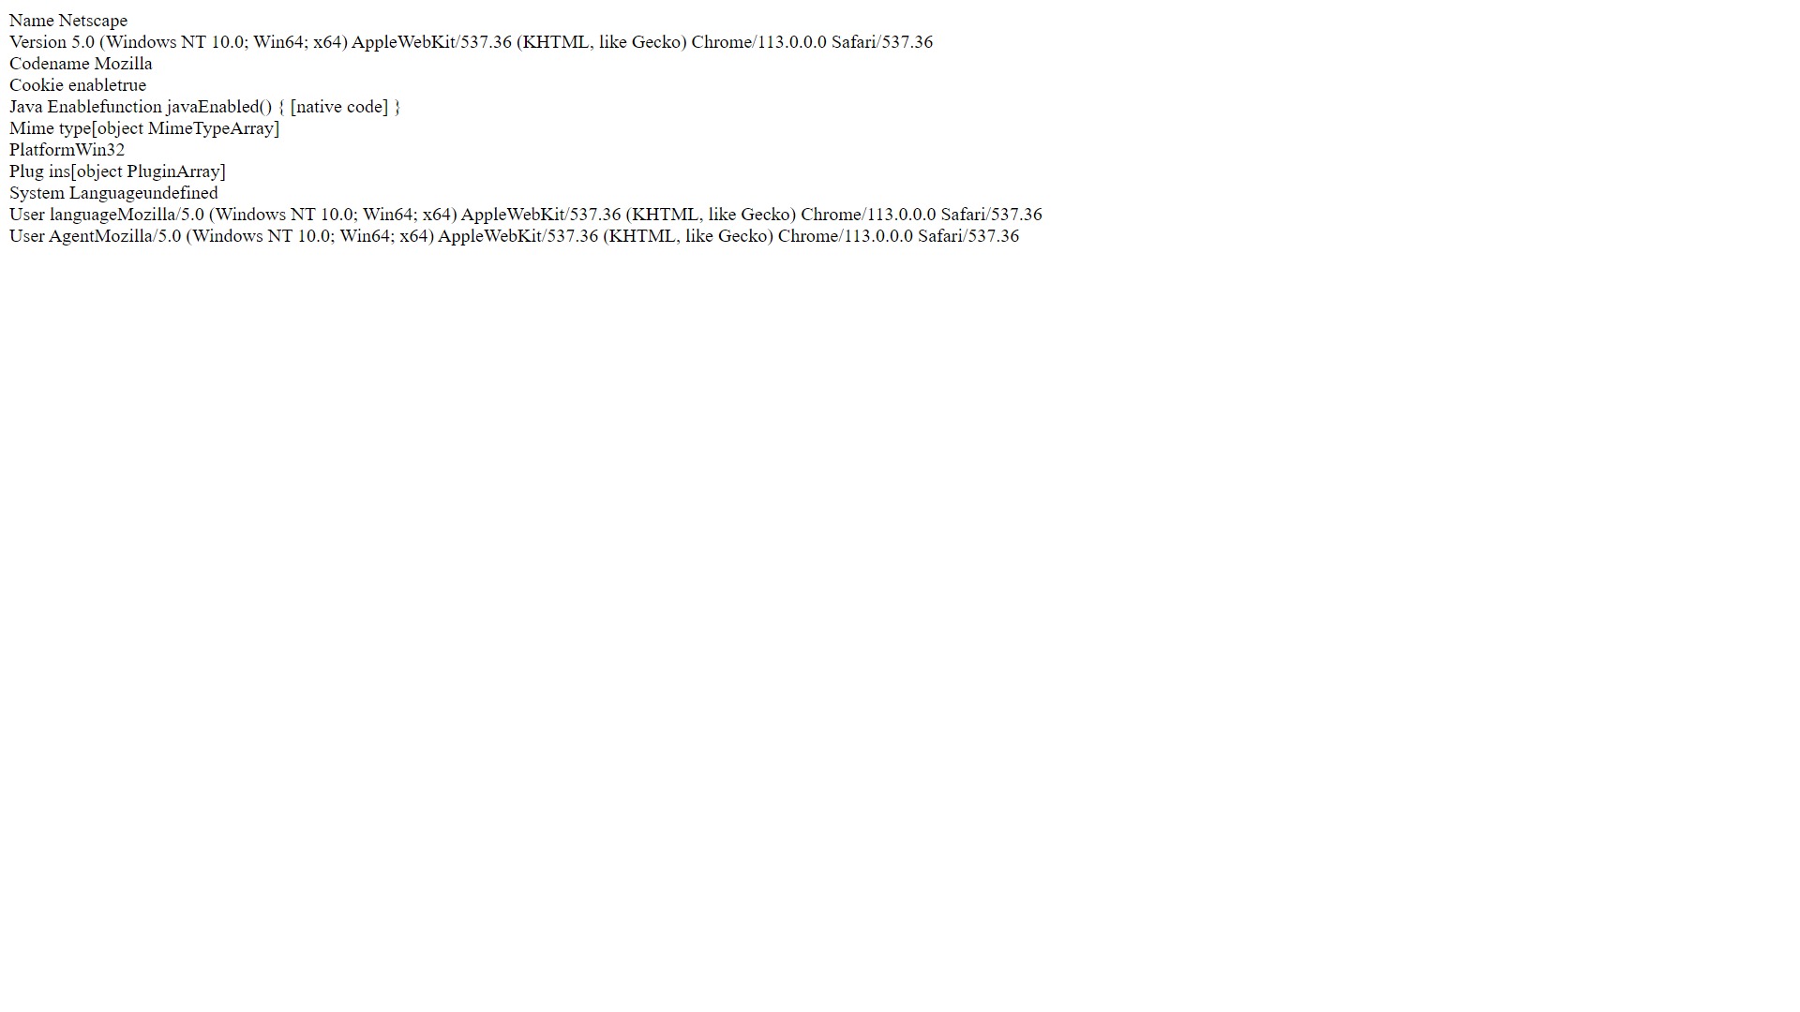

**PROGRAM- 4**

**Objective:** A super class Detail has been defined to store the details of a customer.Define a sub class Bill to compute the monthly telephone charge of the customer as per the chart given below:

|  |  |
| --- | --- |
| **NUMBER OF CALLS** | **RATE** |
| 1-100 | only rental Charge |
| 101-200 | 60 paisa per call + rental charge |
| 201-300 | 80 paisa per call + rental charge |
| Above 300 | 1 rupee per call + rental charge |

**Code:-**

import java.util.Scanner;

class Detail {

protected String name;

protected String address;

protected String telno;

protected float rent;

public Detail(String name, String address, String telno, float rent) {

this.name = name;

this.address = address;

this.telno = telno;

this.rent = rent;

}

public void show() {

System.out.println("Name: " + name);

System.out.println("Address: " + address);

System.out.println("Telephone number: " + telno);

System.out.println("Monthly rental charge: " + rent);

}

}

class Bill extends Detail {

private int n;

private float amt;

public Bill(String name, String address, String telno, float rent, int n) {

super(name, address, telno, rent);

this.n = n;

amt = 0.0f;

}

public void cal() {

if (n <= 100) {

amt = rent;

} else if (n <= 200) {

amt = rent + (0.60f * (n - 100));

} else if (n <= 300) {amt = rent + (0.80f * (n - 200)) + 60.0f;}

else {

amt = rent + (1.0f * (n - 300)) + 140.0f;

}

}

public void show() {

super.show();

System.out.println("Number of calls: " + n);

System.out.println("Amount to be paid: " + amt);

}

}

public class Main {

public static void main(String[] args) {

Scanner scanner = new Scanner(System.in);

System.out.print("Enter customer name: ");

String name = scanner.nextLine();

System.out.print("Enter customer address: ");

String address = scanner.nextLine();

System.out.print("Enter customer telephone number: ");

String telno = scanner.nextLine();

System.out.print("Enter monthly rental charge: ");

float rent = scanner.nextFloat();

System.out.print("Enter number of calls: ");

int n = scanner.nextInt();

Bill b = new Bill(name, address, telno, rent, n);

b.cal();

b.show();

scanner.close();

}

}

**Output :** 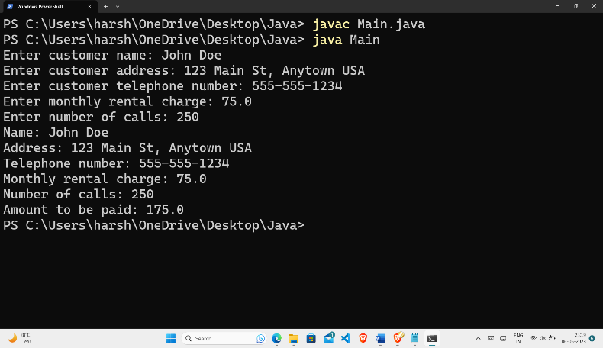

**PROGRAM- 5**

**Objective:** Write a Java applet/AWT to display the ApplicationProgram screen i.e. calculator and other.

**Code**:-

import java.awt.*;

import java.awt.event.*;

import java.applet.*;

/*

<applet code="Cal" width=300 height=300>

</applet>

*/

public class Cal extends Applet

implements ActionListener {

String msg = " ";

int v1, v2, result;

TextField t1;

Button b[] = new Button[10];

Button add, sub, mul, div, clear, mod, EQ;

char OP;

public void init() {

Color k = new Color(120, 89, 90);

setBackground(k);

t1 = new TextField(10);

GridLayout gl = new GridLayout(4, 5);

setLayout(gl);

for (int i = 0; i < 10; i++) {

b[i] = new Button("" + i);

}

add = new Button("add");

sub = new Button("sub");

mul = new Button("mul");

div = new Button("div");

mod = new Button("mod");

clear = new Button("clear");

EQ = new Button("EQ");

t1.addActionListener(this);

add(t1);

for (int i = 0; i < 10; i++) {

add(b[i]);

}

add(add);

add(sub);

add(mul);

add(div);

add(mod);

add(clear);

add(EQ);

for (int i = 0; i < 10; i++) {

b[i].addActionListener(this);

}

add.addActionListener(this);

sub.addActionListener(this);

mul.addActionListener(this);

div.addActionListener(this);

mod.addActionListener(this);

clear.addActionListener(this);

EQ.addActionListener(this);

}

public void actionPerformed(ActionEvent ae) {

String str = ae.getActionCommand();

char ch = str.charAt(0);

if (Character.isDigit(ch))

t1.setText(t1.getText() + str);

else if (str.equals("add")) {

v1 = Integer.parseInt(t1.getText());

OP = '+';

t1.setText("");

} else if (str.equals("sub")) {

v1 = Integer.parseInt(t1.getText());

OP = '-';

t1.setText("");

} else if (str.equals("mul")) {

v1 = Integer.parseInt(t1.getText());

OP = '*';

t1.setText("");

} else if (str.equals("div")) {

v1 = Integer.parseInt(t1.getText());

OP = '/';

t1.setText("");

} else if (str.equals("mod")) {

v1 = Integer.parseInt(t1.getText());

OP = '%';

t1.setText("");

}

if (str.equals("EQ")) {

v2 = Integer.parseInt(t1.getText());

if (OP == '+')

result = v1 + v2;

else if (OP == '-')

result = v1 - v2;

else if (OP == '*')

result = v1 * v2;

else if (OP == '/')

result = v1 / v2;

else if (OP == '%')

result = v1 % v2;

t1.setText("" + result);

}

if (str.equals("clear")) {

t1.setText("");

}

}

}

**Output:-**

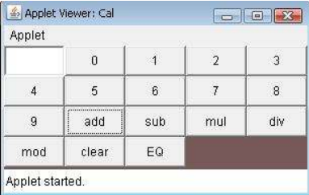

**PROGRAM- 6**

**Objective:** Write a Java applet to display the Application Program screen i.e. Colour mixer pallet

**Code:-**

import java.applet.*;

import java.awt.*;

import java.awt.event.*;

public class ColorMixer extends Applet implements AdjustmentListener {

Scrollbar redSlider, greenSlider, blueSlider;

Label redLabel, greenLabel, blueLabel;

Panel colorPanel;

public void init() {

setLayout(new BorderLayout());

// Create sliders

redSlider = new Scrollbar(Scrollbar.HORIZONTAL, 0, 1, 0, 255);

greenSlider = new Scrollbar(Scrollbar.HORIZONTAL, 0, 1, 0, 255);

blueSlider = new Scrollbar(Scrollbar.HORIZONTAL, 0, 1, 0, 255);

// Add listeners

redSlider.addAdjustmentListener(this);

greenSlider.addAdjustmentListener(this);

blueSlider.addAdjustmentListener(this);

// Create labels

redLabel = new Label("Red: 0");

greenLabel = new Label("Green: 0");

blueLabel = new Label("Blue: 0");

// Create panel for sliders and labels

Panel controlPanel = new Panel();

controlPanel.setLayout(new GridLayout(3,2));

controlPanel.add(redLabel);

controlPanel.add(redSlider);

controlPanel.add(greenLabel);

controlPanel.add(greenSlider);

controlPanel.add(blueLabel);

controlPanel.add(blueSlider);

// Create panel for displaying color

colorPanel = new Panel();

colorPanel.setBackground(Color.black);

// Add panels to applet

add(controlPanel, BorderLayout.NORTH);

add(colorPanel, BorderLayout.CENTER);

}

public void adjustmentValueChanged(AdjustmentEvent e) {

int redValue = redSlider.getValue();

int greenValue = greenSlider.getValue();

int blueValue = blueSlider.getValue();

redLabel.setText("Red: " + redValue);

greenLabel.setText("Green: " + greenValue);

blueLabel.setText("Blue: " + blueValue);

colorPanel.setBackground(new Color(redValue, greenValue, blueValue));

}

}

**PROGRAM- 7**

**Objective:** Write a program using TCP/IP socket between client andserver and perform two-way

communication

**Code:-**

Server.java

import java.net.*;

import java.io.*;

*public* class Server {

*public* *static* void main(String[] *args*) {

*try* {

*// Create server socket*

            ServerSocket serverSocket = *new* ServerSocket(5000);

            System.out.println("Server started...");

*// Accept client connection*

            Socket clientSocket = serverSocket.accept();

            System.out.println("Client connected...");

*// Create input and output streams*

            InputStream inputStream = clientSocket.getInputStream();

            OutputStream outputStream = clientSocket.getOutputStream();

*// Create input and output readers*

            BufferedReader inputReader = *new* BufferedReader(*new* InputStreamReader(inputStream));

            PrintWriter outputWriter = *new* PrintWriter(outputStream, true);

*// Read and write data*

            String inputLine, outputLine;

*while* ((inputLine = inputReader.readLine()) != null) {

                System.out.println("Client: " + inputLine);

                outputLine = "Server received: " + inputLine;

                outputWriter.println(outputLine);

*if* (inputLine.equals("Bye")) {

*break*;

                }

            }

*// Close everything*

            inputReader.close();

            outputWriter.close();

            clientSocket.close();

            serverSocket.close();

        } *catch* (IOException *e*) {

            e.printStackTrace();

        }

    }

}

Client.java

import java.net.*;

import java.io.*;

public class Client {

    public static void main(String[] *args*) {

*try* {

*// Create client socket*

            Socket clientSocket = *new* Socket("localhost", 5000);

            System.out.println("Connected to server...");

*// Create input and output streams*

            InputStream inputStream = clientSocket.getInputStream();

            OutputStream outputStream = clientSocket.getOutputStream();

*// Create input and output readers*

            BufferedReader inputReader = *new* BufferedReader(*new* InputStreamReader(inputStream));

            PrintWriter outputWriter = *new* PrintWriter(outputStream, true);

*// Read and write data*

            BufferedReader userInputReader = *new* BufferedReader(*new* InputStreamReader(System.in));

            String userInput, serverResponse;

*while* ((userInput = userInputReader.readLine()) != null) {

                outputWriter.println(userInput);

*if* ((serverResponse = inputReader.readLine()) != null) {

                    System.out.println("Server: " + serverResponse);

                }

*if* (userInput.equals("Bye")) {

*break*;

                }

            }

*// Close everything*

            userInputReader.close();

            inputReader.close();

            outputWriter.close();

            clientSocket.close();

        } *catch* (IOException *e*) {

            e.printStackTrace();

        }

    }

}

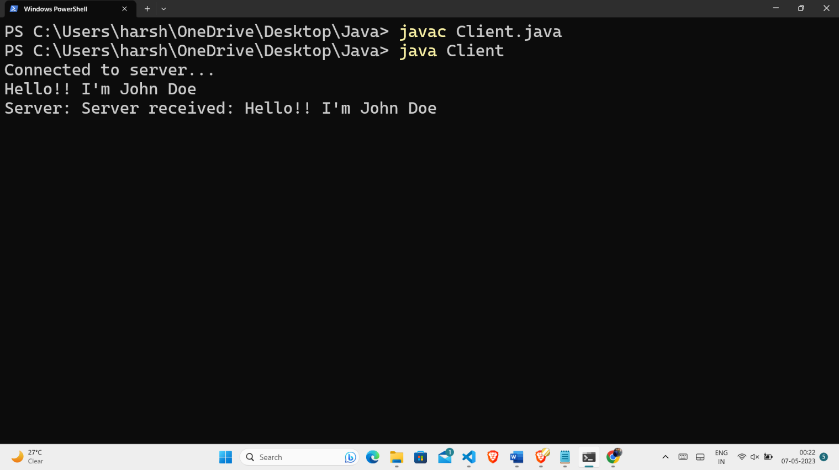**Output:-**

